University of Newcastle Law Students’ Association

2023 Negotiation Competition

COMPETITION HANDBOOK

2023 Negotiation Competition
Why Should You Enter? 3
Contacts 3
Rules 4
Purpose of the Competition 4
Competition Structure 4
Teams 6
Release of Questions 6
Judging 7
The Negotiations 8
Appeal Process 9
Competitions Blacklist 11
Miscellaneous 12
Appendix 13
“A” - Negotiation Marking Guide 13
“B” - Sample Negotiation Problem 16

Why Should You Enter?
The UNLSA holds negotiation competitions to complement your legal education, increase your engagement with Law School, and to find the best students to represent the University of Newcastle at an intervarsity level.

As the cost of litigation escalates, negotiation skills are becoming increasingly important for lawyers of all levels, and approximately 80% of disputes are now being settled by negotiation prior to trial. Prospective employers appreciate the value of educational competitions in developing practical legal skills, and are keen to employ well-rounded individuals. A significant number of successful applicants for clerkship or graduate jobs have been involved in competitions – at University, national or international levels.

The negotiation competition has a strong emphasis on responding to client needs and alternatives proposed by the opposing team during the negotiation. By entering, you will gain valuable skills and experience for future competitions, including those at an intervarsity level, to represent the University of Newcastle Law School and UNLSA.

Contacts
Director of Competitions (Skills) | Katherine Taylor  skills@unlsa.com  0452 077 201
Vice President (Competitions) | Shania Fenton  competitions@unlsa.com  0466 212 235

Rules

Purpose of the Competition
The University of Newcastle Law Students’ Association (UNLSA) has established a Competitions Portfolio to provide as many students as possible with the opportunity to gain valuable practical skills by competing in Educational Competitions and further the UNLSA’s interests. The UNLSA and the Directors of Competitions (Skills) will at all times endeavour to uphold this purpose by promoting involvement, sportsmanship and excellence in educational competitions.

It is the UNLSA’s position that where the implementation of any rule or procedure would be inconsistent with the overarching purpose outlined in this Rule 1, that rule or procedure should not be implemented. An alternative course of action may be determined in order to uphold the purpose of the Competition.

Competition Structure
At the time of this publishing, Negotiation will be run in-person. However, the UNLSA reserves the right to modify the competition format dependent on ongoing advice and restrictions imposed by NSW Health, NSW Government, University of Newcastle and any other key stakeholders.

  - The Competition consists of two preliminary rounds, quarterfinals, semi-finals and a grand final.

  - Preliminary Round Procedures:
    - If an even number of teams enter the Competition, all teams compete in all the preliminary rounds.
    - If an odd number of teams enter the Competition, a bye will be declared for each round. The bye is allocated randomly. A team with a bye will be taken to have won that round.
    - Opposing sides are randomly matched by the Directors of Competitions (Skills).
    - No team negotiates against the same team more than once during the preliminary rounds of the Competition.

  - At the end of the preliminary rounds, each team’s score is totaled and their win/loss ratio calculated. The eight teams with the highest win/loss ratios are the quarter-finalists. Or, if the Directors of Competitions (Skills) determine that no quarter final will be held, then the four teams with the highest win/loss ratios will progress immediately to the semi-finals.

    - In the event that two teams only have tied win-loss ratios, and the two teams have faced each other in the preliminary rounds, then the winner of that round shall proceed to the finals.
    - In the event that the two teams referred to in 2.3.1 have not faced each other, or if there are more than two teams with tied win/loss ratios, the team or teams will progress on the basis of the highest average winning margins.
    - If the teams remain tied, the teams will progress based on a coin toss conducted by the Directors of Competitions (Skills).

  - Finals Procedures:
    - The draw for the quarter-finals is as follows (where Team One is the highest placed team and Team Eight is the lowest placed team):
Quarter-Final A: Team One v Team Eight
Quarter-Final B: Team Two v Team Seven
Quarter-Final C: Team Three v Team Six
Quarter-Final D: Team Four v Team Five
Teams will be allocated to sides randomly.
    - The winner of each quarter final will progress to the semifinals.
    - The draw for the semi-finals is as follows:
Winner of Quarter-Final A v Winner of Quarter-Final D
Winner of Quarter-Final B v Winner of Quarter-Final C
Teams will be allocated sides randomly.
    - In the event that the Directors of Competitions (Skills) determine that no quarterfinal will be held, and the competition progresses directly to the semi-finals, the draw for the semi-finals will be as follows (where Team One is the highest placed team and Team Four is the lowest placed team):
Semi-Final A: Team One v Team Four
Semi-Final B: Team Two v Team Three
    - The winner of each semi-final will progress to the grand final.

  - Notification of winners:
    - Teams progressing through the Preliminary, Quarter-Final and Semi-Final Rounds will be notified by email.
    - The winner of the grand final will be announced immediately after the grand final takes place.

Teams
  - Each team will consist of two people.
  - Each team member must be a member of the UNLSA.
  - Teams must register by the registration date as set out by the Directors of Competitions (Skills). The Directors of Competitions (Skills) may apply penalties for late registration at their discretion.
  - Where one team member cannot compete in a particular round due to extenuating circumstances, the Director of Competitions (Skills) may at their discretion permit substitution. All decisions as to whether substitution will be permitted will be made with reference to section 1 of these rules.
    - In deciding whether to permit substitution, the Director of Competitions (Skills) may consult with the Competitions Appeals Board, or any or all members of the UNLSA Executive.
    - Any member of the UNLSA Executive who is also a competitor should not be consulted by the Director of Competitions (Skills) during the decision-making process.

Release of Questions
  - Negotiation scenarios for the preliminary rounds will be released via email at least twenty-four (24) hours before the Competitions begin.
  - The negotiation scenarios involve two sets of information:
(a) A common set of facts known by all participants; and
(b) Additional confidential information known only to the teams representing a particular side of the negotiation.
  - Legal background material may also be provided to participants if considered by the Directors of Competitions (Skills) to be necessary.
  - There should be no communication between teams regarding the negotiation after the scenarios have been released.
  - In the event that a team has previously seen the question being used for the round (for example, if they have competed in another negotiation competition where the question has been used), they must immediately notify the Directors of Competitions (Skills).
    - If a team fails to notify the Directors of Competitions (Skills) that they have previously seen the question, within 8 hours of receipt of the same day, they may, at the discretion of the competitions organisers, be disqualified from the competition.

Judging
  - Each preliminary round will be observed and evaluated by a single judge.
  - Each finals round will be evaluated by a single judge or a panel of three judges.
  - Judges will be legal practitioners, professionals or senior students with negotiation experience, or Newcastle Law School staff.
  - Where a senior student is serving as a judge, s/he may not judge a team from his/her year.
  - Judges have access to all simulation materials provided to participants.
  - The judge(s) will evaluate the performance of the participants according to the criteria provided.

  - Judging Standards:
    - The judging standards recognise that there is no one "correct" approach to conducting a negotiation. Instead the strategies and techniques used will vary according to the nature of the problem, the personalities involved and other circumstances. However, the effectiveness of a negotiation can be judged, at least in part, by its outcome.
    - Any marking criteria should not be read as requiring that the parties reach an agreement. In some situations, the best outcome might be no agreement at all. Thus, the judging standards (below) focus on planning and the negotiation process itself, allowing a team to achieve a high score even if no agreement was reached.
    - Each panel of judges ranks the teams whom they observe according to their effectiveness in the negotiation session. To assist the process of ranking, judges also score each team against the following standards:
      - NEGOTIATION PLANNING:
Judging from its performance and its apparent strategy, how well prepared did this team appear to be?

      - FLEXIBILITY IN DEVIATING FROM PLANS OR ADAPTING STRATEGY:
How flexible did this team appear to be in adapting its strategy to the developing negotiation, e.g. to new information or to unforeseen moves by the opposing team?
      - TEAMWORK:
How effective were the negotiators in working together as a team, in sharing responsibility, and providing mutual backup?
      - RELATIONSHIP BETWEEN THE NEGOTIATING TEAMS:
Did the way this team managed its relationship with the other team contribute to or detract from achieving its client's best interests?
      - NEGOTIATING ETHICS:
To what extent did the negotiating team observe or violate the ethical requirements of a professional relationship?
      - OUTCOME OF SESSION:
Based on what you observed in the negotiation and the self-analysis, to what extent did the outcome of the session, regardless of whether agreement was reached, serve the client's goals?
      - SELF-ANALYSIS:
Based on what you observed in the reflection period, how well did the negotiating team respond to the self-analysis question and reflect on their chosen strategies?

The Negotiations
  - Each round consists of a 30-minute negotiation session.
    - The Grand Final will consist of a 45-minute negotiation session.
  - As part of the session, each team may take one break of no more than 5 minutes for the team to discuss strategy privately.
  - The 30 or 45-minute period continues to run during any such break.
  - During a break, teams may not confer with any other person.
  - At the end of the negotiation session, each team has a 5-minute period of private reflection to analyse their performance.
  - After the private reflection, each team, in the absence of the opposing team, conducts a 10-minute self-analysis in the presence of the judges. The team should analyse its performance in the negotiation by answering the following questions:
    - In reflecting on the entire negotiation, if you were to be faced with a similar situation tomorrow, what would you do the same and what would you do differently?
    - How well did your strategy work in relation to the outcome?
  - The teams should also be prepared to respond to questions from the judge(s) concerning the team’s performance. In addition, the team may use this as an opportunity to explain why it chose a particular approach or even a specific tactic. The judges may take into consideration for scoring purposes anything said during this session.
  - If resources and volunteers are available, timekeepers may be provided, but no competitors may act as timekeepers in negotiation sessions in which they are not directly competing. If no timekeeper can be provided, responsibility rests with competitors for timekeeping and adherence to time periods and breaks.
  - Decisions by the judges as to elapsed time are final and non-reviewable. Where the judge(s) deem extra time to be necessary for scoring purposes, the judge(s) may allow an extra five minutes (collectively) at the end of the 30-minute negotiation session.

Appeal Process
7.1. A two-stage appeals process exists for decisions made in relation to the Competition.
7.2. The first stage (Stage One) of appeal must be made to the Vice President (Competitions). Should a second stage (Stage Two) of appeal be commenced then the appeal will be reviewed by the Competition Appeals Board.
7.3. Appeals should only be made where the issue has first been raised with the Director(s) of Competitions (Skills).
7.4. Appeals may only be made where they relate to matters other than the decisions of competition judges on the basis of merit. Decisions of judges may not be appealed.
7.5. The Competition Appeals Board will consist of two academic members of Law School Staff and the UNLSA President, or his/her nominee. Where possible, the academic members of the Competition Appeals Board will be the coordinators of the Competitive Mooting directed course or have an academic interest in competitions.
7.6. Decisions made by the Competition Appeals Board are final and may not be appealed.
7.7. The Procedure of Appeals:
7.7.1. When wishing to appeal, the competitor(s) will notify the Director(s) of Competitions (Skills) by email within six hours of the issue arising. The notification should contain the following:
7.7.1.1. Identification of the competition (name, date, time, and parties);
7.7.1.2. Grounds of appeal or grievance or complaint;
7.7.1.3. Arguments supporting the need for review or resolution; and
7.7.1.4. Suggested outcomes.
7.7.2. The Director(s) of Competitions (Skills) will then notify the Vice President (Competitions). The Vice President (Competitions) has the power to:
7.7.2.1. Grant the appeal;
7.7.2.2. Dismiss the appeal; or
7.7.2.3. Direct the appeal to the Competitions Appeals Board.
7.7.3. The Vice President (Competitions) must inform the person or team appealing of the outcome of the appeal by email.
7.7.4. Following a decision being handed down by the Vice President (Competitions), the person or member of the appealing team who lodges the original appeal may further appeal to the Competition Appeals Board within 24 hours of the Vice President (Competitions)’ decision being handed down.
7.7.5. They are to email their Stage Two appeal to the Vice President (Competitions) along with a notification written by that person containing the following:
7.7.5.1. Justification for a review of the decision on grounds other than merit; and
7.7.5.2. Suggested outcomes.
7.7.6. The appeal will then be forwarded to an academic staff member of the Competition Appeals Board who will determine its appropriateness for review by the full Competition Appeals Board.
7.7.7. In determining the appeal, the Competition Appeals Board will consult the Director(s) of Competitions (Skills). The Competition Appeals Board may also consult any or all members of the UNLSA Executive, or any other person(s) deemed necessary.
7.7.7.1. Any member of the UNLSA Executive who is also a competitor should not be consulted by the Competitions Appeals Board during the appeals process.
7.7.8. The Competitions Appeals Board will notify the Director(s) of Competitions (Skills) of their decision, who will then notify the competitor(s).

Competitions Blacklist
8.1 The Competitions Blacklist (found in UNLSA By-Law 47) will be enforced throughout the competition. By-Law 47 has been reproduced below.

47. Competitions Blacklist
1.The Vice President (Competitions) is to create and maintain a Competitions Blacklist.
2.Any member added to the Competitions Blacklist will not be permitted to:
a.compete in any internal competition;
b.be selected for an external competition; and
c.receive a subsidy from the Association to attend an external competition.
3.The Competitions Blacklist must provide blacklisted member’s:
a.name;
b.student number;
c.date blacklisted;
d.period of blacklisting; and
e.reason(s) for blacklisting.
4.The Vice President (Competitions) may add a member to the Competitions Blacklist where that member:
a.withdraws from an internal competition outside of the dates prescribed by the relevant competition directors;
b.is disqualified from an internal competition; or
c.refuses or fails to attend preparations for an external competition that they have been selected for; and
d.fails to provide a reasonable excuse for doing so.
5.If the Vice President (Competitions) adds a member to the Competitions Blacklist, they must provide that member with written notice within reasonable time of doing so, which details:
a. the effect of blacklisting;
b.the reasons for adding them to the Competitions Blacklist;
c.the duration that they have been blacklisted for;
d.the date that the blacklisting will expire; and
e.how they may appeal the decision.
6.A member who is added to the Competitions Blacklist may appeal the decision within seven days of receipt of written notice of their suspension by sending written notice to the Vice President (Administration).
a.Such notice should detail the reasons why the member believes that the blacklisting or duration of the blacklisting is inappropriate.
7.Within reasonable time following receipt of a written notice to appeal, the Vice President (Administration) is to notify the Executive of the appeal who may:
a.dismiss the appeal if it is vexatious or without merit; or
b.convene a Committee Meeting within the next 28 days where the Committee will decide the appeal.
i.If the Committee is to decide the appeal, the Vice President (Administration) is to provide the relevant member of written notice of that decision, and invite them to that Committee Meeting.
8.At a Committee Meeting where a Competitions Blacklisting Appeal is to be decided:
a.The Vice President (Competitions) is to provide a short explanation of the reasons for the Blacklisting;
b.The relevant Member is to provide a short explanation as to the reasons for their appeal; and
c.The Committee, after hearing those reasons, is to vote by show hands, either in favour of or against the appeal.
9.The Committee’s decision in a Competitions Blacklisting Appeal is final.

Miscellaneous
9.1. In the event that an issue arises that is not covered by the rules of the Competition, the Directors of Competitions (Skills) may consult:
9.1.1. The UNLSA Executive or UNLSA Committee;
9.1.2. Newcastle Law School staff;
9.1.3. ALSA rules and ALSA; or
9.1.4. Any other person(s) they deem necessary.

Appendix

“A” - Negotiation Marking Guide

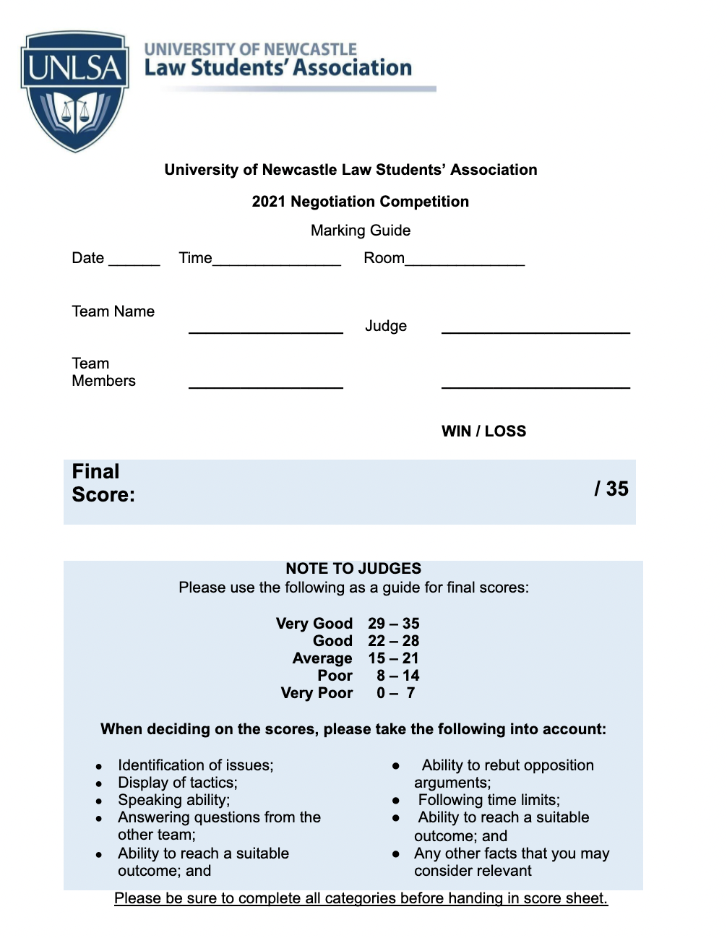

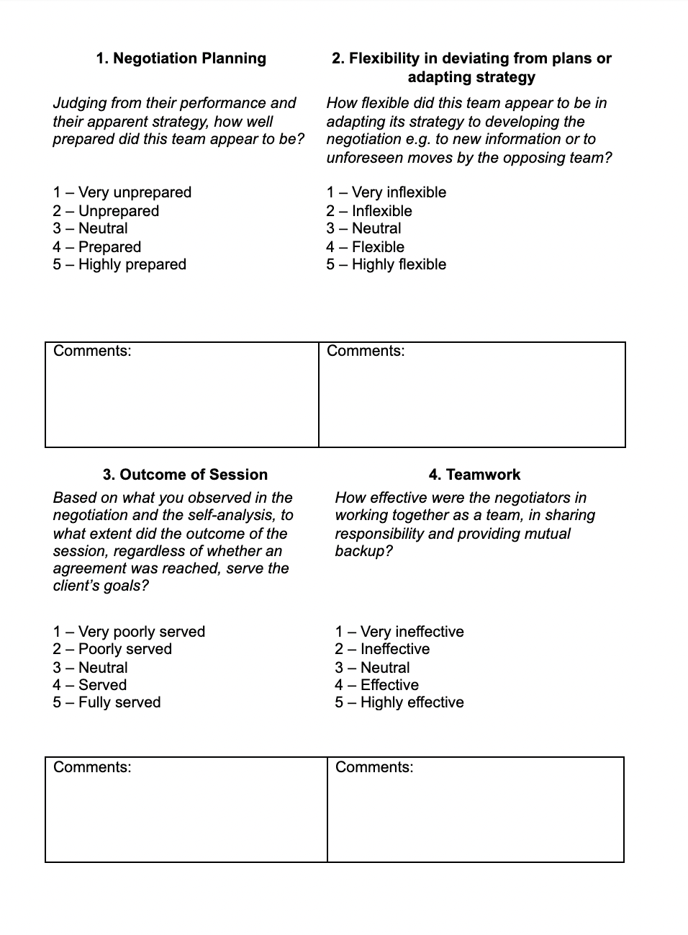
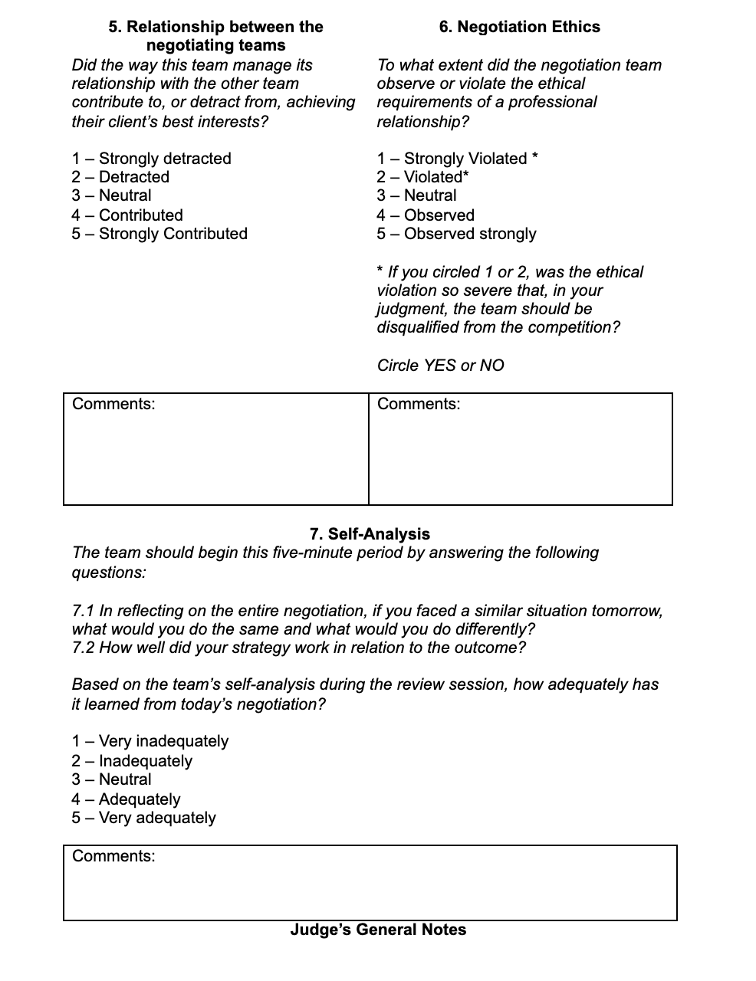

“B” - Sample Negotiation Problem

SCENARIO: JULIETTE ROYD & ANTHONY EYEMANN

General Information for both parties

In April 2001, at the age of 24, Juliette Royd was fairly content with her life. She was studying her third year of Medicine at Adelaide University and was looking forward to the day she would become a doctor. She lived in a small flat which she shared with her best friend and worked part-time at a local bakery. However, all that started to change when Juliette’s love of music led to her and some friends forming a small band. Juliette was the lead singer. They devoted many hours each week to practice and soon began performing publically.

In June 2001, Juliette was approached after a performance by Anthony Eyemann, the sole director of Eye Music Pty Ltd. Eye Music is a medium-sized company which both records and distributes music. Anthony had inherited the company from his uncle in May 2001, before which he had never had any experience in the music industry. He told Juliette that her skill was impressive and that she could be successful as a solo artist. He suggested that she visit Eye Music’s office to discuss the possibility of recording a solo album. Naturally, Juliette jumped at the chance.

The first meeting occurred on 14 June 2001. Normally Eye Music’s Artist Relations Officer, the experienced Bob Anderson, would have conducted the meeting, but he was on holidays in Vanuatu. Neither Anthony nor Juliette had ever had such a meeting before, but after a quick discussion they reached a verbal agreement to “test the water”. The conversation ended with Anthony saying, “Well, that’s settled then. You come back in two weeks we’ll record a few songs and make it into an album, then I’ll distribute it to a few local stores and see what the reaction is.” Juliette agreed and left. Probably owing to both parties’ lack of experience, no discussion of rights or payments occurred.

Two weeks later Juliette returned to Eye Music and recorded four songs which she had written herself. She named the album “Orange Midnight”. Juliette meant to ask about getting paid, but forgot all about it in the excitement of the moment. As agreed, Eye Music’s staff created CDs of “Orange Midnight” and sold them to retail music stores in the Adelaide city centre. Specifically, Eye Music sold 500 CDs at $10 each to the music stores, which retailed them for $15, but these figures were not mentioned to Juliette at the time.

“Orange Midnight” was a great success, with the CDs selling out rapidly and Eye Music receiving large orders for more, both from local music stores and national chains. Anthony called Juliette on 14 July 2001 to tell her the good news. “We can make 5,000 more CDs and start shipping them out straight away. We’ll pay you in November, when they should have sold out – because you’re such a hit I’ll pay you 20% of the price!” he told her. Juliette was overjoyed and agreed, adding, “Go for it; do whatever’s best” but also asked whether or not there should be any form of written contract.

Anthony advised her that he thought it would be a good idea and promised to discuss it with Bob when he returned from his extended holiday. Over the course of the next few months Eye Music sold another 5,000 CDs at $15 each to music stores, which retailed them for $20 each. While Juliette’s fame grew throughout the music community, she continued to study medicine and work at a bakery, happy to let Eye Music distribute the CD in the certainty that she’d be paid for it in November. In October the CDs sold out and Eye Music quickly made another 1,500 to satisfy demand, although Juliette only discovered this in November. Again, these CD’s had a wholesale price of $15 and a retail price of $20.

November 2001 arrived and Anthony asked Juliette in to discuss her future. He told her, quite correctly, that there was strong demand for more of her work and asked if she’d like to record a lengthier album with Eye Music. She agreed. However, Bob Anderson had finally returned from his holiday and was ready at the meeting with a written contract. Before signing the contract Anthony told Juliette, “it contains all our normal terms for a recording contract”. Juliette signed without reading the contract in any great detail. The contract contained the following clause:

5.3. The company will pay the artist 10% of the price of each CD sold.
5.4 The first payment is to be made six months after the recording date, and from then every three months until all the CDs have been sold.
5.5 The artist agrees to transfer all rights over all songs on the CD to the company.
5.6 The company agrees to protect the interests of the artist in producing the CD as far as is reasonably possible.

These are indeed normal terms of Eye Music’s recording contracts.

At the same meeting Juliette raised the issue of payment for “Orange Midnight” and was told that a cheque was being processed and would be sent within a fortnight.

Juliette recorded the second album, named “Scarlet Morning” on 20 November 2001. It consists of 11 songs she wrote during the preceding months. Anticipating good sales, Eye Music produced 5,000 CDs which it sold to music stores at $20 each, to be retailed at $25 each. These have all now sold to consumers.

In early December 2001 Juliette received a cheque from Eye Music for $7,500 as payment for “Orange Midnight”. Given that she had expected a cheque for $27,500, she was somewhat surprised and contacted Anthony. Anthony only laughed, telling her that she was dreaming. The conversation became quite heated and soon the pair were also arguing over the regularity of payment for “Scarlet Morning” and the rights to use the songs in it.

Additionally, to Juliette’s horror, she found that “Scarlet Morning’ had been released with two songs by other performers on it. Anthony told her that this is common way of promoting new artists, but Juliette is devastated that she has been used to advertise people she considers to be her competitors.

Since then Anthony and Juliette have not been able to discuss the matter reasonably and have both sought legal advice. They have agreed to a negotiation session between their lawyers in the hope of finding a resolution to their disputes and possibly restoring the chance of continuing their business relationship.

CONFIDENTIAL INFORMATION FOR JULIETTE’S LAWYERS

Juliette Royd first came to your firm in tears claiming that she was a singer being pushed around by a nasty record label. She is a shy but friendly person who, unfortunately, has been somewhat naïve in her dealings with Eye Music Pty Ltd and its director, Anthony Eyemann.

Her first complaint is the amount she has been paid for “Orange Midnight”. She believes that she is entitled to $27,500, based on the following calculations:

June 2001: 500 CDs @ $15 each: $7500
July 2001: 5000 CDs @ $20 each: $100,000
October 2001: 1500 CDs @ $20 each: $30,000
Total sales: $137,5000

20% as agreed: $27,500

She is completely outraged at Anthony’s cheque for $7,500 and does not understand how he can arrive at such a figure based on their agreement. She firmly believes that she is owed another $20,000 for “Orange Midnight”and doesn’t want to accept anything less than $18,000.

Juliette’s second issue is the payment for “Scarlet Morning”. She understands that she has been foolish by signing a contract she had not completely read, but still feels that she has been misled in That she thought that Eye Music’s normal payment to artists was 20%, based on her conversation with Anthony in July 2001. Ideally, she would like $50,000 for her second album, but recognizes she may have to accept $25,000.

Juliette has also been deeply hurt by the inclusion of other artists on her album and feels she should be compensated in some way. She isn’t really sure what options might be open to her, and leaves it to your discretion to get the best deal for her based on her interests below.

Unknown to anyone else but you, Juliette has chosen to devote all her time to her musical career.
She has withdrawn from her course at university and resigned from her job. In expectation of these payments she has run up a lot of debt and has little cash having already spent the$7,500 she’s received so far for “Orange Midnight”. She certainly cannot afford to go to court.

Accordingly, Juliette’s highest priority is to get as much cash as she can from Eye Music as quickly as possible. She is willing to sacrifice up to $5,000 if she can get the second payment earlier than 20 May 2002 – the sooner the better. Additionally, Juliette is willing to drop all arguments regarding the rights over the songs on the second album in the pursuit of funds, although she has mentioned that while she did write all of them, some of her friends from her old band have “done a lot of editing to them to get them right”. She would like to retain the rights to her first album if possible but can sacrifice them if necessary.

Lastly, Juliette is still in high demand in the music industry and has received quiet, informal approaches from other record companies interested in signing her up for a third album. She would be willing to consider signing on for a third album with Eye Music Pty Ltd if it meant she could get extra funds now.

CONFIDENTIAL INFORMATION FOR ANTHONY’S LAWYERS

Anthony Eyemann inherited Eye Music Pty Ltd from his uncle only a month before he first met Juliette. He came to you seeking advice on what he describes as “some record deals which have come back to bite me”.

With regard to “Orange Midnight”, Anthony considers that the cheque for $7,500, which he believes Juliette has cashed, was payment in full. He calculates this as follows:

July 2001: 5000 CDs @ $15 each: $75,000

Normal payments terms of 10%: $7,500

He states that he was simply being encouraging and jocular when he made the comment about paying Juliette 20% and always believed she’d understand that his company’s terms are the industry Standard of 10%. He does not believe that Juliette is entitled to be paid for the first 500 CDs, as he was doing Juliette a favour by seeing if there was any demand for her music, and she never mentioned being paid for them. However, he does recognise that while Juliette never had an agreement to be paid for the last batch of 1,500, she may be entitled to payment anyway and is reluctantly prepared to pay up to $2,250, calculated as follows:

1500 CDs @ $15 each: $22,500

Normal payment terms of 10%: $2,250

In total he does not wish to pay more than $15,000 (including the $7,500 already paid) for the first album.

Anthony now regrets adding the other artists to “Scarlet Morning” but feels that he must stand by his actions, for to admit a mistake in the music industry is suicide. He is prepared to make it up to Juliette somehow so long as it doesn’t cost him more than $10,000 and it’s kept very quiet. Ideally, he’d like the compensation to be something other than a simple cash payment.

Anthony is also aware that artists are regularly “head-hunted” for contracts in the music industry. He regards Juliette as having great potential and does not want to lose her to a competing firm, so he would be interested in paying a little extra to secure at least another two albums.

Under no circumstances is Anthony prepared to negotiate with regard to the rights over use of the songs on the second album. They must be held by Eye Music Pty Ltd at all costs. If possible, Anthony is interested is seeing whether there is any way in which he can assert ownership of the rights to the first album, or alternatively, obtain those rights.

Other than the rights of use, Anthony’s priorities in this negotiation are seeing that he does not incur too many extra expenses. While Eye Music Pty Ltd has the financial resources to go to court, Adelaide is a small city and stories of companies fighting artists in court constitute very damaging publicity. Therefore Anthony would prefer to avoid court if possible, but is willing to litigate if Juliette is highly unreasonable.

ISSUE SUMMARY FOR JUDGES

This is a fairly simple problem to start the competition and give the competitors, many of whom are in their first year of law studies, a chance to find their feet. It involves a contractual dispute between a singer, Juliette Royd, and Anthony Eyemann, director of Eye Music Pty Ltd, which has released two of Juliette’s albums. The parties are disputing how much Juliette is entitled to be paid for the two albums.

The most obvious issues which will probably arise during the negotiation are:
- whether the artist’s percentage is calculated from the wholesale price or the retail price of the album –the parties only ever referred to “the price”;
- whether the artist should be paid 10% or 20% of “the price” for the first album;
- whether Juliette is entitled to be paid for the first batch of CDs from the first album, which was done to “test the water”, i.e. see if there was demand for the product;
- whether Juliette is entitled to be paid for the third batch of CDs from the first album, which was made without any input from her;
- when Juliette is to be paid;
- who holds the intellectual property over the songs on the albums;
- whether Juliette will re-sign for further albums with Eye Music Pty Ltd.

Additionally a remedy for a possible contractual breach has been left very open to encourage some creativity in finding resolutions.

Please note that in the scenario Anthony seems to be more at fault than Juliette. Naturally the competitors should not be judged on this but on how they respond to their client’s goals given their position.

Some of these should not be hard to resolve. Anthony is insisting on keeping the intellectual property and Juliette is willing to give it up. Both parties are interested in using re-signing as a bargaining chip to their advantage.

Other matters will require more discussion. The total payment amounts for the two albums differ considerably between the two sides and their desired limits of payment don’t overlap (e.g., Anthony doesn’t want to pay more than $15,000 for the first album, but Juliette doesn’t want to Settle for less than $18,000).

Due to time constraints it may not be possible for competitors to reach agreement on all issues. In this event they should be judged on the basis of the way they proceeded and the issues which they did address.

